AI Customer Complaint Resolver – Gen AI – Gemini API

Project Description:
AI Customer Complaint Resolver is a Generative AI-powered support workspace that turns a raw customer complaint into a structured, actionable analysis. A support agent pastes or types a complaint, and the application returns its category, customer sentiment and priority, a short complaint summary, a recommended resolution, and a customer-ready reply draft — so the agent can move from reading a frustrated message to sending a thoughtful response in a single step rather than writing every reply from scratch.
Built with Python and Streamlit, the application is organised into three focused modules: app.py renders the interface and orchestrates each request, ai_engine.py sends the complaint to a large language model and shapes the response into a consistent structure, and database.py stores every analysed complaint in a local SQLite database (complaints.db). A Complaints History tab lets the team search and filter earlier cases, a quick-fill menu offers ready-made examples (Order Delay, Refund Issue, Damaged Product and Payment Failure), and a Download Analysis button exports the result. The tool deliberately keeps a human in the loop: the AI suggests a resolution and a reply, but it does not execute refunds or any other business action, and users are reminded not to enter passwords, PINs, OTPs or other sensitive details.

Scenarios
Scenario 1: A support executive receives a message saying an order has not arrived for two days and that nobody has replied. She selects the “Order Delay” quick-fill example, clicks Analyze Complaint, and receives the category, a negative sentiment rating, a priority level, a recommended next step and an empathetic reply she can review and send.
Scenario 2: A customer reports a refund that has not been credited and a payment that failed. The agent loads the “Refund Issue” or “Payment Failure” example, or pastes the real message, and the system classifies the issue, flags how urgent it is and drafts a reply that acknowledges the problem and asks only for the details needed to investigate — without requesting any sensitive information.
Scenario 3: A buyer complains that the griddle supplied with a product is held in place by cheap plastic knobs that come off after heat and washing, so the griddle can only sit at the bottom of the basket. The tool identifies this as a product-design complaint, assesses the sentiment and priority, and proposes a resolution the team can review before replying.
Scenario 4: A customer who bought an air fryer compares it with a rival model and asks customer service for the material and chemical composition of the heating element. The analysis classifies the case as Product Performance & Material Safety with Negative sentiment and Medium priority, recommends escalating to the product engineering and compliance team, and drafts a reply asking for the model number and order details.
Scenario 5: A team lead opens the Complaints History tab, searches for a keyword or filters by category, and expands any saved case — including positive feedback and compliments, which are tagged Low priority — to review the original message and the AI-generated result. This lets the team spot repeated product issues and separate praise from problems that need action.

Technical Architecture:
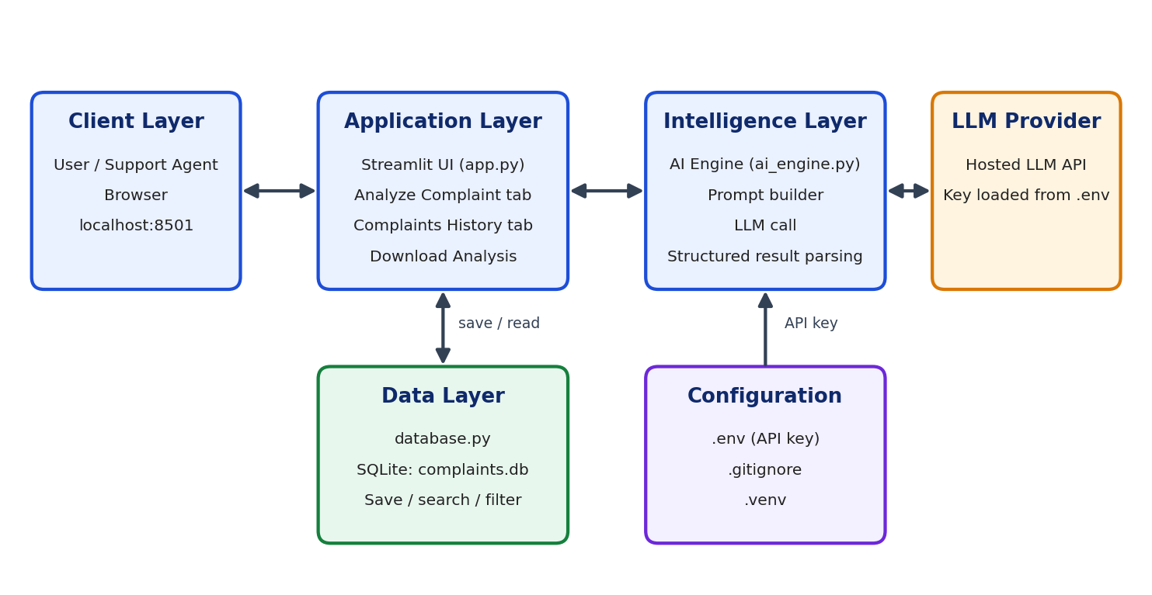
Description: The application follows a four-layer flow. The client layer is the browser, where the agent enters a complaint and reads the analysis. The application layer is the Streamlit interface in app.py, which validates the input, shows the Analyze Complaint and Complaints History tabs and offers the download. The intelligence layer, ai_engine.py, builds the prompt, calls the hosted large language model using the API key stored in the .env file, and parses the reply into category, sentiment, priority, summary, resolution and suggested reply. The data layer, database.py, saves every result in the local SQLite database complaints.db and serves the history search and filter.
ER Diagram:

Pre-requisites:
- Streamlit Framework Knowledge: Streamlit Documentation
- Large Language Model API Familiarity: Understanding how to create an API key, send a prompt and read a response from a hosted LLM provider.
- Python Programming Proficiency: Python Documentation
- SQLite and SQL Basics: SQLite Documentation
- Virtual Environments: Python venv Documentation
- HTML and CSS Basics: Custom CSS is used to style the Streamlit interface — sidebar, header badge and result cards.
- Version Control with Git: Git Documentation

Project Workflow:

Activity 1: Model Selection and Architecture
- Activity 1.1: Generate an LLM API key and configure it securely in the project environment file.
- Activity 1.2: Select the generative AI model suited to complaint classification, sentiment detection and empathetic reply drafting.
- Activity 1.3: Define the application architecture across app.py, ai_engine.py and database.py.
- Activity 1.4: Set up the development environment with a virtual environment and the required libraries.

Activity 2: Core Functionalities Development
- Activity 2.1: Design the complaint database schema and the save, search and filter functions in database.py.
- Activity 2.2: Build the AI analysis engine in ai_engine.py that returns a structured result for every complaint.
- Activity 2.3: Add input limits, privacy guidance and a human-review safeguard around the AI output.

Activity 3: App.py Development
- Activity 3.1: Build the Analyze Complaint workflow — quick-fill examples, complaint input and result display.
- Activity 3.2: Build the Complaints History workflow with search and category filtering.
- Activity 3.3: Add the Download Analysis export and status messages.

Activity 4: Frontend Development
- Activity 4.1: Design the branded layout — gradient sidebar, header, tabs and cards — using custom CSS.
- Activity 4.2: Create result components for category, sentiment and priority, the summary, the resolution and the suggested reply.

Activity 5: Deployment
- Activity 5.1: Prepare the application for local deployment and run it with Streamlit.
- Activity 5.2: Test and verify every feature path locally.

Activity 6: Conclusion
- Activity 6.1: Summarise the project outcome — a Streamlit application that analyses a customer complaint and returns its category, sentiment, priority, summary, recommended resolution and a suggested reply.
- Activity 6.2: Review the safeguards built into the tool — the 5,000-character input limit, the privacy reminder and the human-review notice stating that the AI does not execute refunds or other business actions.
- Activity 6.3: Highlight the value of the Complaints History tab, which stores every analysis locally and lets the team search and filter past cases to spot recurring issues.
- Activity 6.4: Outline future enhancements such as multilingual support, bulk complaint upload, ticketing-system integration and complaint-trend dashboards.

Milestone 1: Model Selection and Architecture
In this milestone the focus is on choosing the generative AI model that powers the Complaint Resolver and on defining how the application is structured around it. Because the tool must read emotionally charged, loosely written customer messages and return a consistent structured analysis plus a polite reply, the model is evaluated on instruction following, tone control and response speed rather than on raw size alone.

Activity 1.1: Generate an LLM API Key
Before the application can communicate with the language model, you need a valid API key from your chosen provider. Follow the steps below to create one and connect it securely to the project.
- Step 1 — Create a Provider Account: Sign up on the API console of your chosen LLM provider using your email or Google account.
- Step 2 — Navigate to API Keys: Open the API Keys section of the console.
- Step 3 — Create a New API Key: Click “Create API Key” and give it a descriptive name (for example, complaint-resolver-key) so it is easy to identify later.
- Step 4 — Copy the Key: Copy the key immediately and store it safely — most consoles show it only once.
- Step 5 — Add the Key to Your Project: Open the .env file in the project root and paste the key using the variable name that ai_engine.py reads:
API_KEY=your_copied_api_key_here
- Important — Never Commit Your API Keys: The project already contains a .gitignore file. Make sure it lists the environment file so the key is never pushed to a public repository:
.env

Activity 1.2: Research and Select the Appropriate Generative AI Model
- Understand the Project Requirements: The model must classify a complaint into a category, judge its sentiment and priority, summarise it, recommend a resolution and draft an empathetic customer reply — all from free-form text of up to 5,000 characters.
- Compare Candidate Models: Evaluate available hosted models on instruction adherence, ability to follow a fixed output structure, tone quality of the reply and latency, since agents wait for the result on screen.
- Prefer Structured, Predictable Output: Choose a model that reliably returns every required field so the interface can render each card and the database can store each value without manual clean-up.
- Balance Quality, Speed and Cost: A fast, affordable model is preferred because every complaint triggers one request and the tool is used repeatedly during support shifts.
- Finalise the Model: Select the model that gives the best balance of accurate classification, natural-sounding replies and quick response, and configure it in ai_engine.py.

Activity 1.3: Define the Architecture of the Application
- Draft an Architectural Diagram: Create a visual representation covering the Streamlit interface, the AI engine, the LLM provider and the SQLite database, as shown in the Technical Architecture section.
- Separate Responsibilities: Keep the interface in app.py, all model interaction in ai_engine.py and all persistence in database.py, so each module can be tested and changed independently.
- Plan the Data Flow: Complaint text enters through the interface, passes to the AI engine, returns as a structured result, is displayed to the agent, and is saved to complaints.db for later review.
- Keep Secrets Out of Code: Load the API key from the environment file at start-up rather than writing it into any source file.

Activity 1.4: Set Up the Development Environment
- Install Python and Pip: Ensure Python 3.8 or later is installed on your machine along with pip for dependency management.
- Create and Activate a Virtual Environment: Keeping the project’s libraries isolated avoids version conflicts with other projects. The project folder uses a .venv environment:

python -m venv .venv
.venv\Scripts\activate # For Windows
source .venv/bin/activate # For macOS/Linux

- Install the Required Libraries: Install Streamlit and the other project dependencies inside the activated environment (for example with pip install streamlit).
- Confirm the Project Structure: The project folder contains app.py, ai_engine.py, database.py, the complaints.db database, README.md, the .env and .gitignore files, the .venv environment and the auto-generated __pycache__ folder.
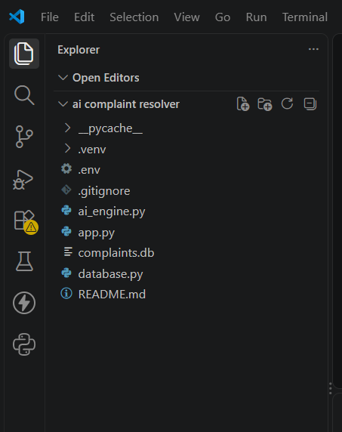

Milestone 2: Core Functionalities Development
Milestone 2 establishes the data model and the analysis engine that sit beneath every screen of the application: the persistence layer in database.py, the AI analysis engine in ai_engine.py and the safeguards that keep the output safe and reviewable.

Activity 2.1: Design the Complaint Database Schema
All persistence is handled by a single local SQLite database, complaints.db, managed by database.py. Using SQLite keeps the project dependency-free — no database server is needed — and the History tab describes its contents as results saved in the local database.
- Create the Table on Start-up: database.py prepares the complaints table when the application starts, so a fresh machine works without any manual set-up.
- Store the Full Analysis: Each saved row keeps the original complaint together with the category, sentiment, priority, summary, recommended resolution and suggested reply, so a case can be reopened exactly as it was analysed.
- Assign a Running Identifier: Every complaint receives an incrementing number that is shown in the history list (#13, #12, #11 …), making cases easy to refer to.
- Support Search and Filtering: Functions in database.py return saved complaints to the interface, which matches a search phrase against the complaint, category and summary and filters by category.

Activity 2.2: Build the AI Analysis Engine
ai_engine.py is the only module that talks to the language model. It receives the complaint text from app.py and returns a consistent result the interface can render without further processing.
- Build a Structured Prompt: The prompt instructs the model to act as a customer-support analyst and to return the category, sentiment, priority, a one-paragraph complaint summary, a recommended resolution and an empathetic customer-ready reply.
- Classify the Category: The category is generated from the content of the complaint, which is why the history list shows specific labels such as Product Specifications, Product Performance & Material Safety and Product Defect / Replacement Availability.
- Detect Sentiment and Priority: Each complaint is rated for sentiment (for example Negative) and priority (for example Low or Medium), so urgent cases can be handled first and compliments can be recognised as low priority.
- Recommend a Resolution: The engine proposes the next business step — for example escalating a material-safety question to the product engineering and compliance team and offering return or warranty guidance once the order is verified.
- Draft the Customer Reply: The reply acknowledges the customer’s frustration, restates the issue, explains what the team will do and asks for any missing details such as the model number and order details.
- Return a Clean Result: The model output is converted into the individual fields used by the interface and the database, so every card on the results screen is filled consistently.

Activity 2.3: Add Input Limits, Privacy Guidance and Human Review
- Limit the Input Length: The complaint box accepts up to 5,000 characters and shows a live counter (for example 262/5000), keeping every request within a safe size for the model.
- Protect Sensitive Data: A visible note reminds users not to enter passwords, PINs, OTPs or unnecessary sensitive details, since complaint text is sent to an external model and saved locally.
- Keep a Human in the Loop: Beneath the results, the app states that the suggested resolution and reply should be reviewed before use and that the AI does not execute refunds or other business actions.
- Keep Data Local: Saved complaints stay in the local SQLite file on the machine running the application.

Milestone 3: App.py Development
Milestone 3 focuses on app.py, the file that runs the Streamlit interface and connects the user’s actions to the AI engine and the database. In this milestone you build each workflow, handle user input safely and make sure every result is displayed and saved correctly.

Activity 3.1: Build the Analyze Complaint Workflow
- Configure the Page: Set the page title and layout, apply the custom styling and build the sidebar and header shown on every screen.
- Create the Two Tabs: Use Streamlit tabs to provide the “Analyze Complaint” and “Complaints History” views.
- Add the Quick-fill Menu: A “Quick-fill an example” dropdown offers four ready-made complaints — Order Delay, Refund Issue, Damaged Product and Payment Failure — that fill the complaint box so the tool can be demonstrated instantly.
- Capture the Complaint: A text area labelled “Customer complaint” collects the message, shows an example placeholder, enforces the 5,000-character limit and supports Ctrl+Enter to submit.
- Run the Analysis: Clicking “Analyze Complaint” sends the text to ai_engine.py; an empty submission is rejected with a message rather than sent to the model.
- Display and Save the Result: The returned analysis is shown in the results panel, saved through database.py, and confirmed with the message “Complaint analyzed and saved.”
- Offer the Download: A “Download Analysis” button exports the result so it can be attached to a ticket or shared with a colleague.

Activity 3.2: Build the Complaints History Workflow
- Load Saved Complaints: Read all saved cases from complaints.db through database.py, newest first.
- Add Search: A search box matches the typed phrase against the complaint text, category and summary.
- Add the Category Filter: A dropdown, defaulting to “All Categories”, narrows the list to a single category.
- Show Counts and Details: A line such as “Showing 13 of 13 saved complaints” tells the user how many cases match, and each case appears as an expandable row headed by its number, category and priority.

Activity 3.3: Handle Errors and Status Messages
- Validate Before Calling the Model: Check that the complaint is not empty and is within the length limit.
- Show Clear Progress and Outcomes: Indicate that the analysis is running, and show a success message or a readable error if the model or database call fails.
- Preserve the User’s Text: Keep the typed complaint in the box after analysis so the agent can refine it and run it again.

Milestone 4: Frontend Development
Milestone 4 focuses on a clear and visually consistent interface. Although Streamlit supplies the basic widgets, custom CSS is layered on top to give the Complaint Resolver a polished “Smart Support Desk” identity with a persistent sidebar, card-based results and a clear two-column workspace.

Activity 4.1: Designing and Developing the User Interface
- Build the Sidebar: A deep-blue gradient sidebar carries the app logo, an “AI support workspace” introduction, an “AI-powered support” highlight card and a four-step “How it works” guide: Enter a complaint, Analyze with AI, Review the recommendation, Download the result.
- Design the Header: A large title with the words “Customer Complaint Resolver” highlighted in blue, a one-line description and a “Smart Support Desk” badge on the right.
- Use a Two-column Workspace: “Submit a Complaint” sits on the left and “Analysis Results” on the right, so the agent sees the input and the outcome side by side.
- Provide an Empty State: Before any analysis, the results panel shows a friendly “Your analysis will appear here” placeholder explaining what will be produced.
- Style the Controls: A rounded, gradient “Analyze Complaint” button, a soft-bordered text area and clear helper text keep the form easy to scan.

Activity 4.2: Creating the Result Components
- Summary Cards: Three coloured cards show the Category, the Sentiment and the Priority at a glance — for example Product Performance & Material Safety, Negative and Medium — with a distinct tint for each so urgency is visible immediately.
- Complaint Summary: A short paragraph restating the customer’s issue in neutral language.
- Recommended Resolution: A highlighted card describing the next business step for the team.
- Suggested Customer Reply: A full, ready-to-review reply in a polite and empathetic tone.
- Download and Review Notice: A prominent “Download Analysis” button followed by a reminder that the AI does not execute refunds or other business actions.

Milestone 5: Deployment
In Milestone 5 the focus is on running the Complaint Resolver locally and verifying that every feature works end to end. Because Streamlit serves the application directly, no separate web server configuration is needed.

Activity 5.1: Preparing the Application for Local Deployment
- Activate the Virtual Environment: Open a terminal in the project folder and activate the .venv environment so the correct libraries are used.
- Confirm the Environment File: Make sure the .env file contains your API key before launching.
- Initialise the Database: complaints.db is created and used automatically by database.py the first time the application runs.

Activity 5.2: Local Testing and Verification
- Start the Streamlit Application: From the project folder, run the following command:
streamlit run app.py
- Confirm the Server Has Started: The terminal reports that the server has started on port 8501, after which the app opens in the browser at localhost:8501.
- Verify Every Feature Path: Work through each workflow before sharing the application:
- Quick-fill: choose each of the four examples and confirm that the complaint box is filled.
- Analysis: submit a complaint and confirm that the category, sentiment, priority, summary, resolution and reply all appear and that the message “Complaint analyzed and saved.” is shown.
- Download: click Download Analysis and confirm that the file is saved.
- History: open Complaints History, confirm the new case appears at the top, then test the search box and the category filter.
- Limits: confirm the 5,000-character counter works and that an empty submission is rejected.

Exploring the Website’s Web Pages:

Analyze Complaint Page :
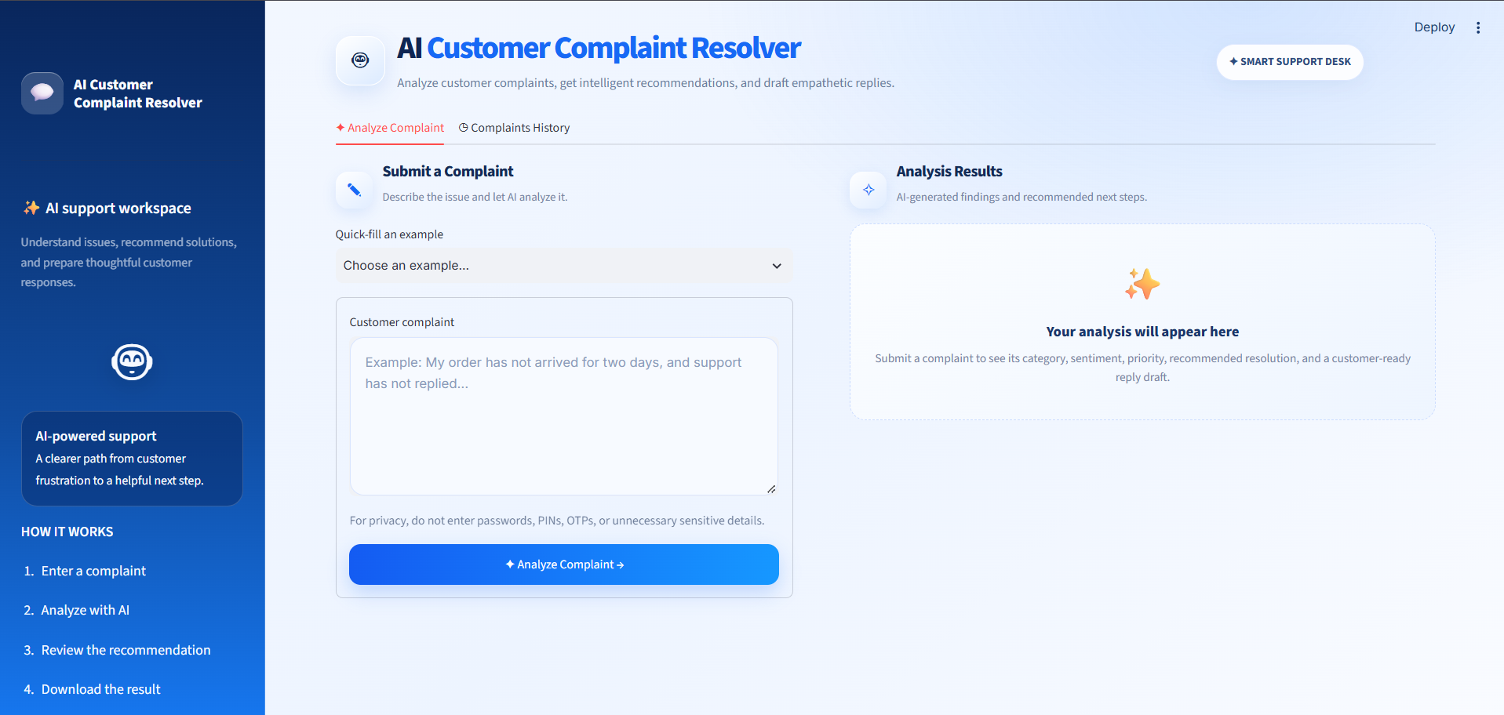
Description: The landing screen of the Smart Support Desk. The sidebar introduces the “AI support workspace” and lists the four steps — enter a complaint, analyze with AI, review the recommendation and download the result. In the main area, the “Submit a Complaint” panel holds a quick-fill dropdown and a text area with an example placeholder, followed by a privacy reminder and the blue Analyze Complaint button. The “Analysis Results” panel on the right shows an empty state explaining that the category, sentiment, priority, recommended resolution and a customer-ready reply draft will appear once a complaint is submitted.

Quick-fill Examples:
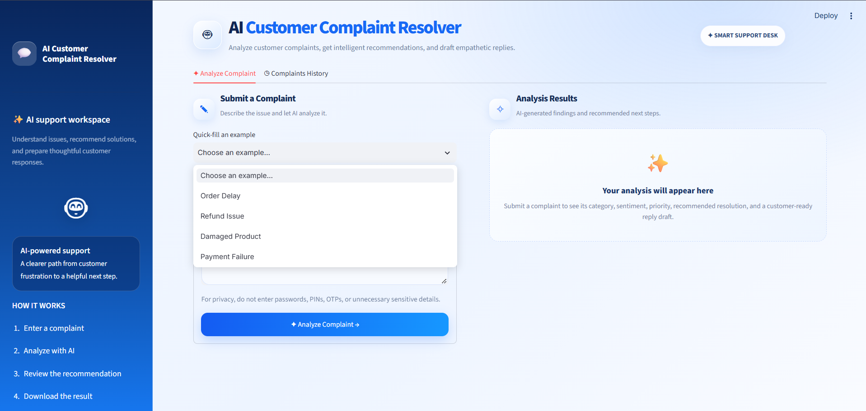
Description: The “Quick-fill an example” dropdown offers four ready-made complaints — Order Delay, Refund Issue, Damaged Product and Payment Failure. Selecting one fills the complaint box, which makes it easy to demonstrate the tool or to test a new prompt without typing a full message.

Entering a Complaint:
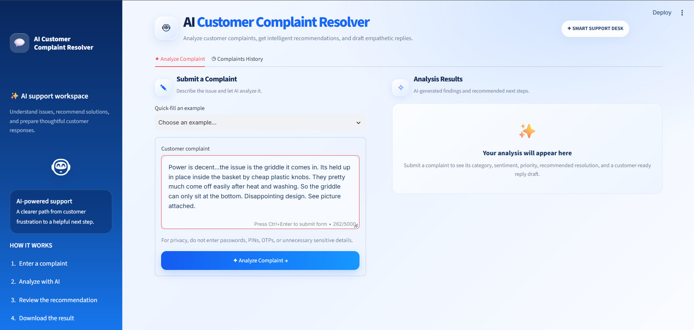
Description: A real customer complaint about a griddle held in place by cheap plastic knobs has been entered. The text area shows the live character counter (262/5000) and the “Press Ctrl+Enter to submit form” hint, and the border highlights while the box is active. The agent can edit the text before clicking Analyze Complaint.

Analysis Results Page:
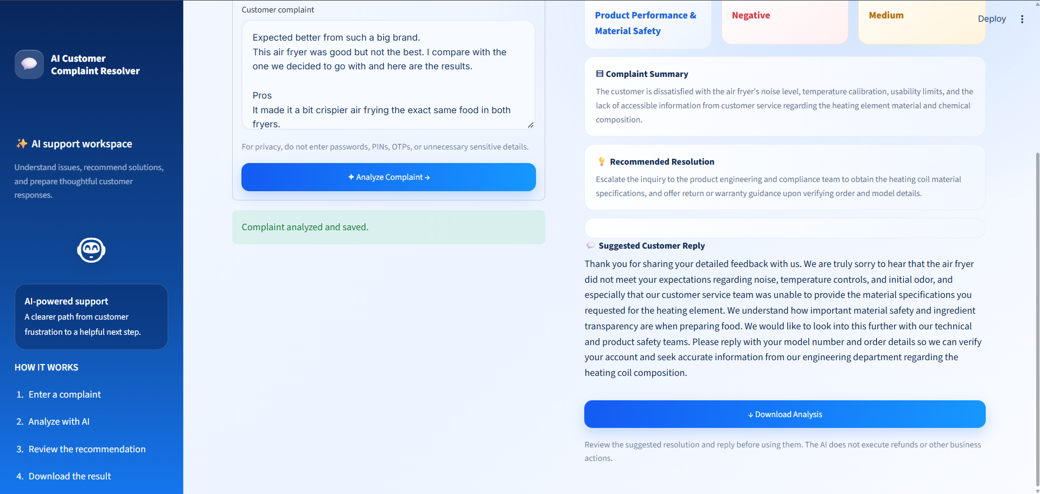
Description: After analysis, the results panel shows three summary cards — Category (Product Performance & Material Safety), Sentiment (Negative) and Priority (Medium) — followed by the Complaint Summary, the Recommended Resolution and the Suggested Customer Reply. In this example the customer is dissatisfied with an air fryer and with customer service’s inability to share the heating element’s material details; the recommendation is to escalate to the product engineering and compliance team and offer return or warranty guidance once the order is verified, and the drafted reply asks for the model number and order details. A green message confirms “Complaint analyzed and saved.”, a Download Analysis button exports the result, and a note reminds the agent to review the suggestions because the AI does not execute refunds or other business actions.

Complaints History Page:
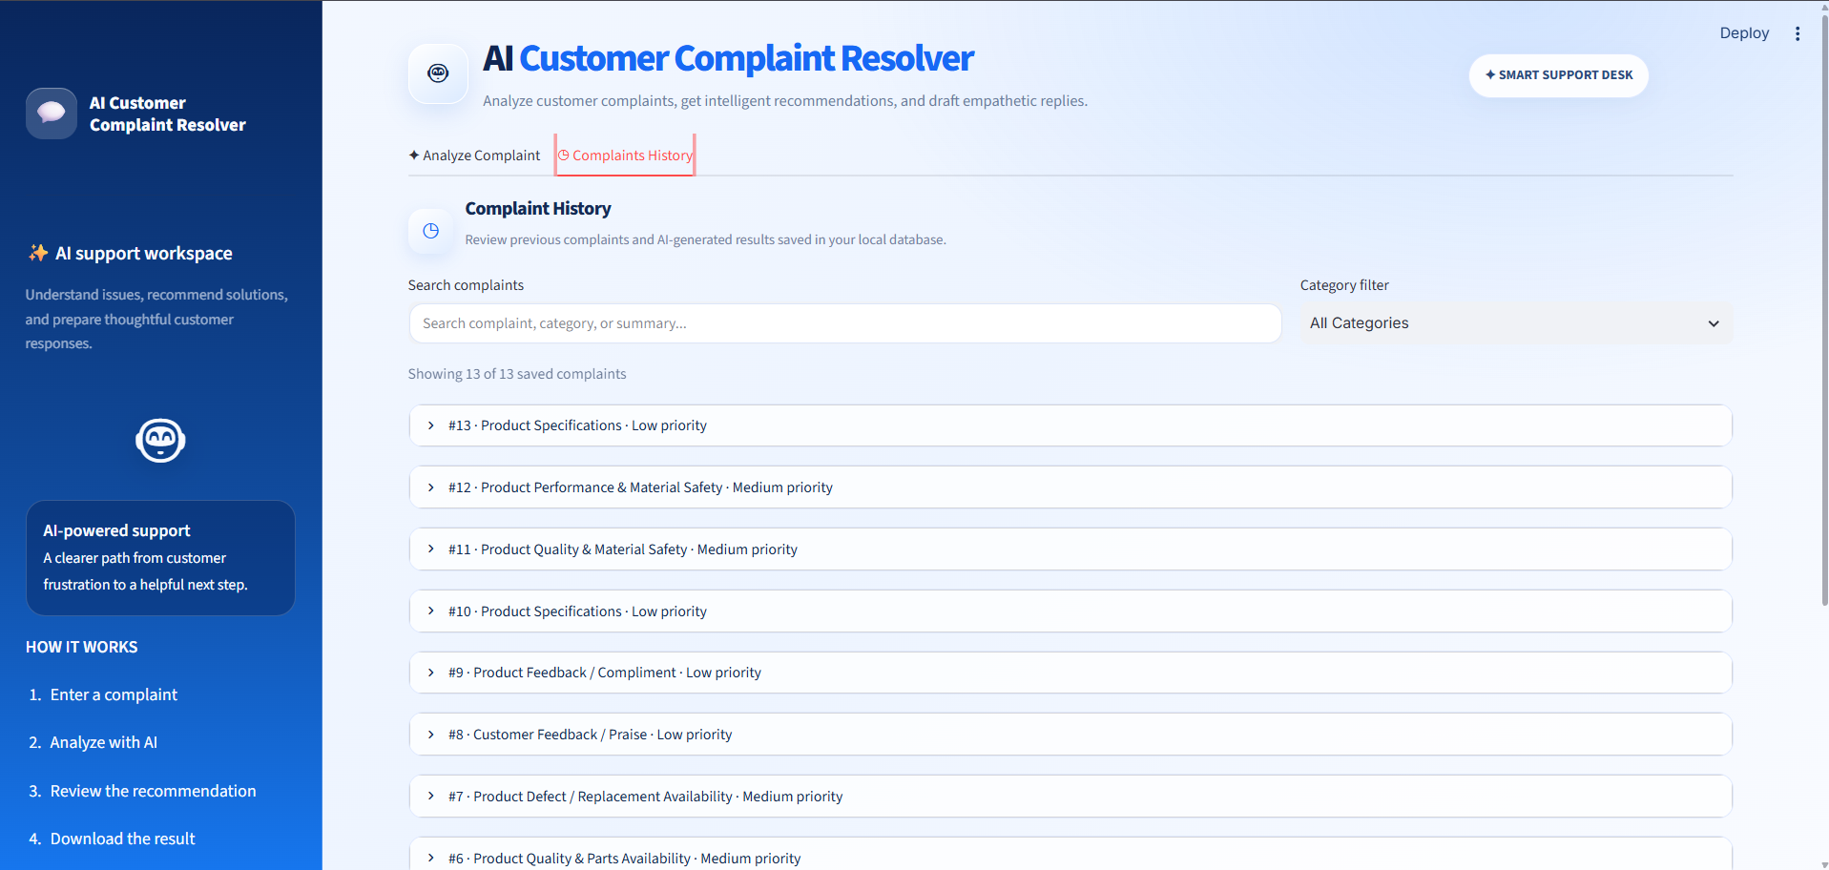
Description: The history tab lists previous complaints and their AI-generated results saved in the local database. A search box matches the complaint text, category or summary, and a category filter defaults to All Categories. The counter reads “Showing 13 of 13 saved complaints”, and each case is an expandable row headed by its number, category and priority — for example “#12 · Product Performance & Material Safety · Medium priority” or “#9 · Product Feedback / Compliment · Low priority”. The mix of categories shows that the model creates specific labels from each complaint, and that praise is correctly recognised as low priority.

Conclusion:
AI Customer Complaint Resolver is a Generative AI-powered support tool built using Python, Streamlit and SQLite, designed to turn an unstructured customer complaint into a clear analysis and a ready-to-review reply. Instead of leaving an agent to read, interpret and respond from scratch, the platform categorises the complaint, measures sentiment, assigns a priority, summarises the issue, recommends a resolution and drafts an empathetic message in a single step.
The application is organised into three focused modules. app.py provides the Streamlit interface with its Analyze Complaint and Complaints History tabs, ai_engine.py handles all communication with the language model and returns a consistent structured result, and database.py stores every analysis in the local complaints.db database. This separation keeps the code easy to understand, test and extend.
A major objective of the project is to speed up support work without removing human judgement. The suggested resolution and reply are always presented for review, the interface states clearly that the AI does not execute refunds or other business actions, and users are reminded not to enter passwords, PINs, OTPs or unnecessary sensitive details. Input is limited to 5,000 characters to keep requests safe and predictable.
The Complaints History tab turns individual analyses into a searchable record, with text search and category filtering across every saved case. Over time this helps a team spot recurring product problems, separate compliments from complaints that need action and prioritise urgent cases. The Download Analysis feature makes each result easy to share.
The project can be extended in several directions, such as support for multiple languages, bulk upload of complaints, ticketing-system integration and dashboards for complaint trends. In its current form, AI Customer Complaint Resolver demonstrates a practical, India-market-ready use of Generative AI for customer support: fast to use, transparent about its limits and built on a simple stack that can be run on any laptop.

